Introduction to Cyber Security
Homework Practice Documentation

Programming Task 2 – Implementation and Integration of Classical Cartographic Algorithms

Authors: L6HXIR, Sharukh Rahman
Institute: Óbuda University – John von Neumann Faculty of Informatics
Major: Data Science
Training Mode: Daytime training
Semester: 2025 – 09 - 01

Written Summary of Task
The project fulfills Programming Task 2 requirements by implementing three fundamental cryptographic algorithms—Group Substitution Cipher, Vigenère Cipher with an extended alphabet, and Columnar Transposition Cipher—together with a Diffie–Hellman key exchange as an additional component. Each algorithm has been developed from first principles, without reliance on external cryptographic libraries, to provide full transparency of the encryption and decryption processes.

The implemented algorithms have been integrated into a full-stack web application that issues and manages JWT-like tokens with the structure header.payload.signature. Each token segment is protected using a distinct classical cipher: the header is encrypted with the Group Substitution Cipher, the payload with the Vigenère Cipher, and the signature with the Columnar Transposition Cipher. The Diffie–Hellman module demonstrates secure shared-key negotiation, enabling the illustration of key exchange principles in a web-based interface.

The system supports tiered subscription management (Free / Basic / Premium), with token-based authentication, authorization and permissions. User features are dynamically restricted according to subscription level, and access enforcement is maintained across browser tabs through local storage and reactive verification mechanisms.

The report documents the theoretical foundations, algorithmic specifications, and system architecture, and it details the token lifecycle, authentication and authorization flows, permission management, and testing procedures. The resulting application serves as an educational tool to illustrate classical cryptographic methods in a practical, interactive setting, providing insight into encryption mechanics, token verification, and secure key exchange protocols.

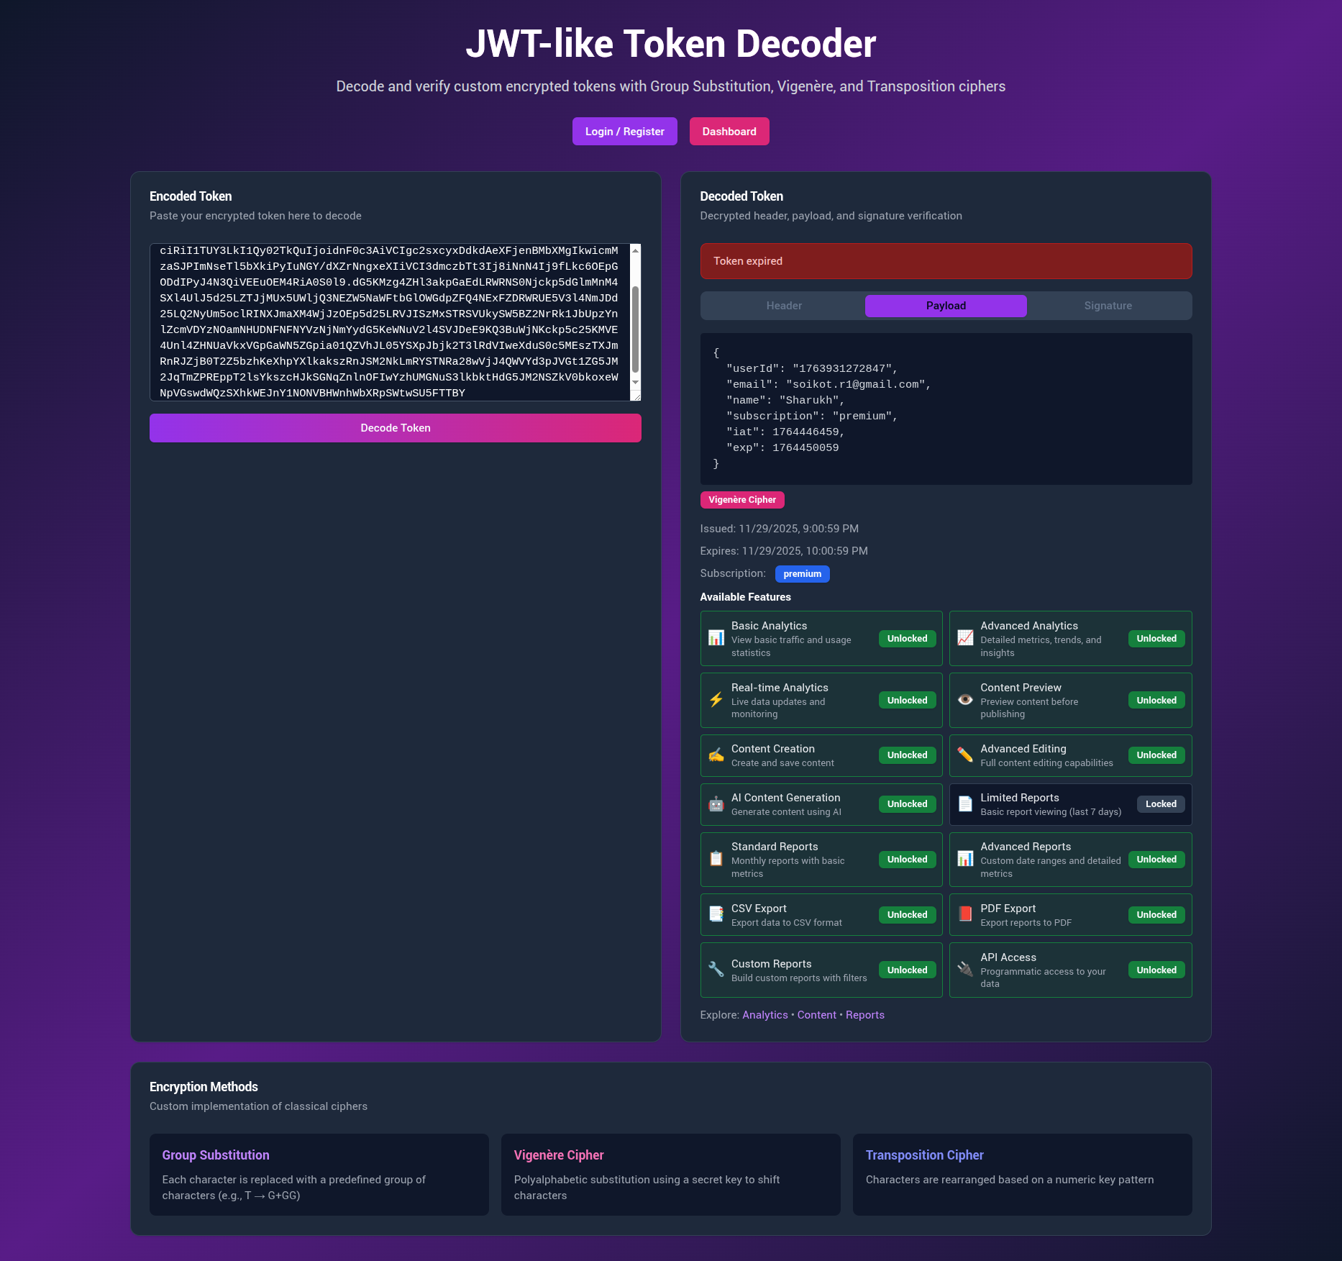
Figure 1: Home page of implemented website

System Architecture and Design

High-Level Architecture
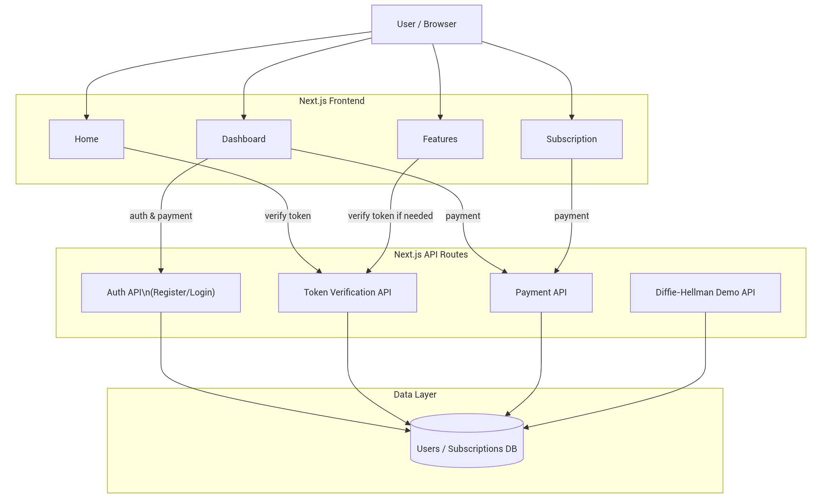
Figure 2: High-Level System Architecture

The system employs a client‑centric architecture where the user interacts directly with four frontend pages—Home, Dashboard, Features, and Subscription—that orchestrate the application experience. The Home and Features pages optionally invoke the Token Verification API to validate tokens, while the Dashboard and Subscription pages authenticate users and process payments through the Auth and Payment APIs, respectively. These backend API routes handle core logic: Auth manages user registration and login against a database, Payment processes subscription upgrades via both the internal database and Stripe gateway, Token Verification ensures token integrity and subscription checks, and the Diffie‑Hellman Demo API facilitates key exchange demonstrations. All backend services persist data to a centralized database, with the Payment API additionally interfacing with Stripe for real‑world transaction processing, creating a cohesive flow from user action through business logic to persistent storage.

Encryption and Decryption Design
JWT-like Token Architecture
The implemented algorithms have been integrated into a full-stack web application that issues and manages JWT-like tokens with the structure header.payload.signature. This tripartite structure, inspired by JSON Web Tokens (JWT) as specified in RFC 7519, provides a standardized format for representing claims between parties. Each token segment is protected using a distinct classical cipher: the header is encrypted with the Group Substitution Cipher, the payload with the Vigenère Cipher, and the signature with the Columnar Transposition Cipher. The Diffie–Hellman module demonstrates secure shared-key negotiation, enabling the illustration of key exchange principles in a web-based interface. This architectural decision maximizes pedagogical value by making each cryptographic operation visible and independently analyzable while maintaining ergonomic compatibility with existing JWT tooling and mental models.

The header contains metadata about the token type and encryption algorithm. The payload carries user claims including identifier, subscription tier, and temporal constraints (issued-at iat and expiration exp timestamps). The signature ensures integrity by binding the header and payload through cryptographic transformation. Base64 encoding is applied to each encrypted segment to ensure safe transmission in HTTP contexts, with padding removed for compactness and re-added during decoding. This design deliberately eschews modern HMAC or RSA signatures in favor of classical ciphers to make the entire transformation pipeline inspectable and comprehensible for educational purposes

The token has three parts (like JWT): header.payload.signature

Header
- Encrypted with Group Substitution Cipher
- Contains token metadata
- Example: {"alg":"CUSTOM","typ":"JWT"}
Payload
- Encrypted with Vigenère Cipher
- Contains data for example:
- User ID
- Email
- Name
- Subscription tier
- Expiration time
Signature
- Encrypted with Transposition Cipher
- Ensures token hasn't been tampered with
- Validates token integrity

The token creation pipeline uses three distinct ciphers to independently protect each segment of the JWT-like token:

Group Substitution Cipher (Header)

- Purpose: Provides deterministic obfuscation of the token header JSON.
- Mechanism: Each character is mapped to a predefined group string (e.g., H → S+SS) using a static, invertible substitution table.
- Reversibility: Fully reversible; decryption reconstructs the original header from the group representation.
- Application: Ensures that the header metadata (algorithm type, token type) is obscured, illustrating classical substitution techniques in a web-based token.

Vigenère Cipher (Payload)

- Purpose: Provides confidentiality for the token payload, which contains user data, issued-at (iat), and expiration (exp) timestamps.
- Alphabet: Extended set comprising A–Z, a–z, 0–9, and select punctuation (.,;:!?-_).
- Key: Default key is SECRETKEY.
- Mechanism: Each plaintext character is shifted according to the position of the corresponding key character in the alphabet. Characters not in the alphabet are left unchanged.
- Reversibility: Decryption reverses the shift using the same key.
- Application: Demonstrates symmetric classical encryption applied to structured JSON payloads within a web application.
Columnar Transposition Cipher (Signature)

- Purpose: Ensures integrity of the token by encrypting the concatenated Base64-encoded header and payload.
- Key: Default key 34152 determines column order.
- Mechanism:
- Fill a row-major grid with the input text, padding as needed.
- Read columns according to ascending key digits to generate the encrypted signature.
- Decryption reconstructs the grid column-wise and reads row-wise to verify integrity.
- Application: Serves as a classical method for integrity verification of token segments before client-side consumption.

Implementation Details

Method 1: Group Substitution Cipher
Purpose: JWT’s Header section encryption through deterministic character-to-group mapping.
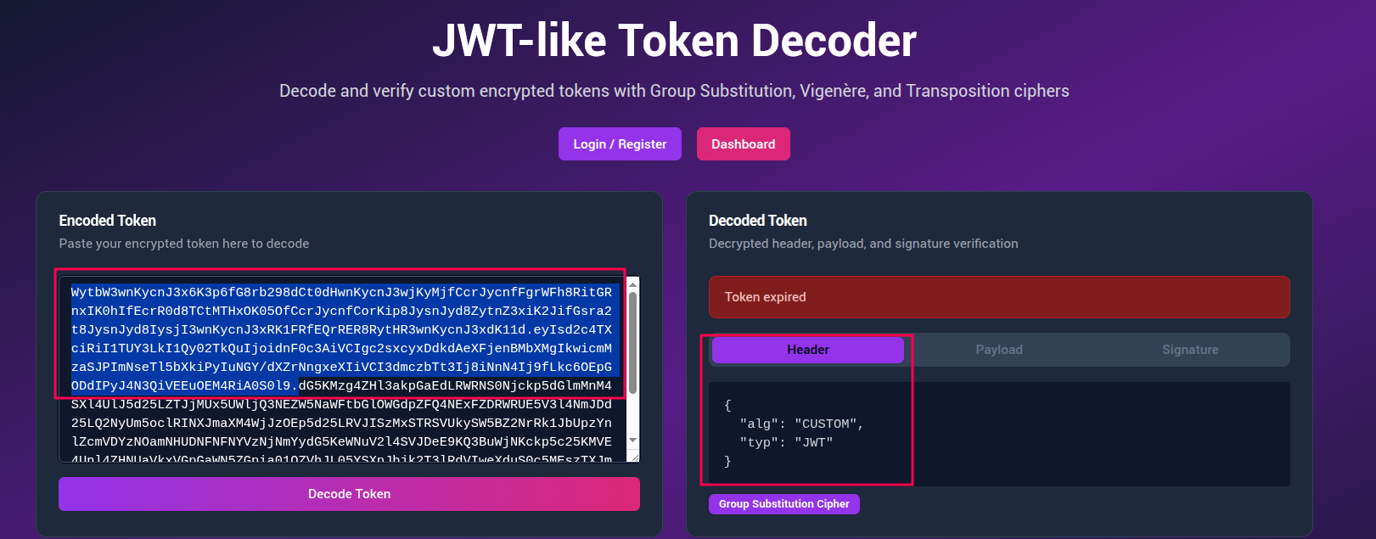
Figure 3: JWT’s Header Section

Algorithm Specification: The cipher uses a fixed bidirectional mapping where common characters transform into symbolic groups. For example:
H → S+SS
E → V+VV
L → O+OO
Unknown characters fallback to C+CC pattern
Pseudocode - Encrypt:
function encryptGroupSubstitution(plaintext):
MAP = { 'A': 'B+BB', 'B': 'C+CC', ..., 'H': 'S+SS', ... }
output = []
for character in plaintext:
if character in MAP:
output.append(MAP[character])
else:
output.append(character + "+" + character + character)
return "|".join(output)

Pseudocode - Decrypt:
function decryptGroupSubstitution(ciphertext):
REVERSE_MAP = invert(MAP)
groups = ciphertext.split("|")
output = []
for group in groups:
if group in REVERSE_MAP:
output.append(REVERSE_MAP[group])
else:
output.append(group.split("+")[0])
return "".join(output)

Usage Context: Encrypts token header JSON ({"alg":"CUSTOM","typ":"JWT"}) to produce obfuscated yet structured ciphertext.

Method 2: Vigenère Cipher
Purpose: Payload encryption using polyalphabetic substitution with keyword.
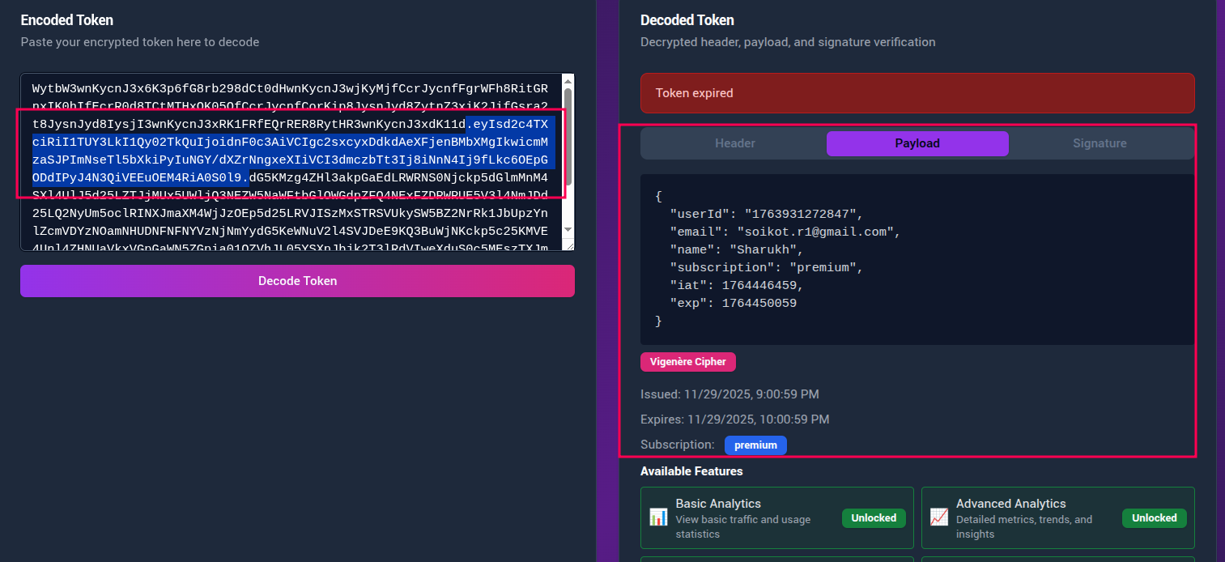
Figure 4: JWT’s Payload Section

Alphabet Specification:
ALPHABET = "ABCDEFGHIJKLMNOPQRSTUVWXYZabcdefghijklmnopqrstuvwxyz0123456789 .,;:!?-_"
Length: 74 characters (A-Z, a-z, 0-9, space, punctuation)
Key: Default "SECRETKEY" (configurable)

Each plaintext character's index is shifted forward by the key character's index modulo alphabet length. Non-alphabet characters pass through unchanged.

Pseudocode - Encrypt:
function vigenereEncrypt(plaintext, key):
output = []
keyIndex = 0
for char in plaintext:
pIdx = ALPHABET.indexOf(char)
if pIdx == -1:
output.append(char)
continue
kChar = key[keyIndex % len(key)].upper()
kIdx = ALPHABET.indexOf(kChar)
newIdx = (pIdx + kIdx) % len(ALPHABET)
output.append(ALPHABET[newIdx])
keyIndex += 1
return "".join(output)

Pseudocode - Decrypt:
function vigenereDecrypt(ciphertext, key):
output = []
keyIndex = 0
for char in ciphertext:
cIdx = ALPHABET.indexOf(char)
if cIdx == -1:
output.append(char)
continue
kChar = key[keyIndex % len(key)].upper()
kIdx = ALPHABET.indexOf(kChar)
newIdx = (cIdx - kIdx + len(ALPHABET)) % len(ALPHABET)
output.append(ALPHABET[newIdx])
keyIndex += 1
return "".join(output)

Usage Context: Encrypts token payload containing user claims, subscription tier, and timestamps. The cipher's key-based operation demonstrates_secret key cryptography principles.

Method 3: Transposition Cipher

Purpose: Signature generation through character permutation.
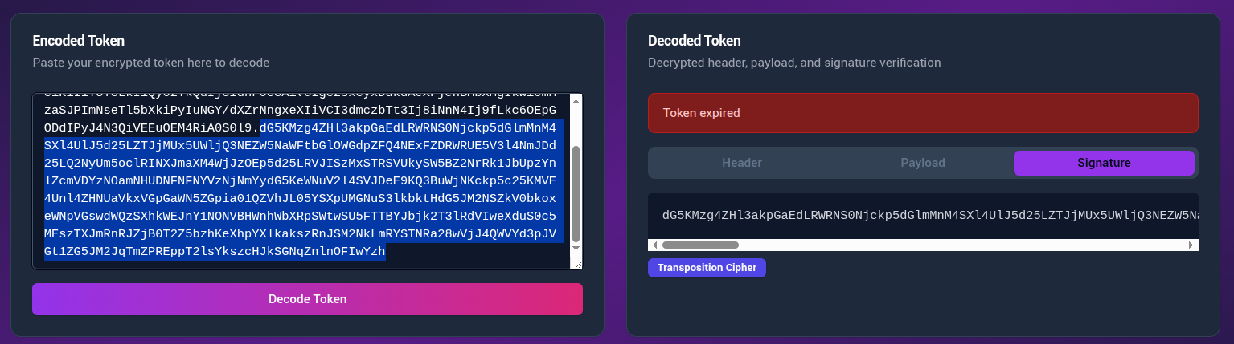
Figure 5: JWT’s Signature Section

Key: "34152" (numeric digits define column read order)
Algorithm Specification:
Plaintext is written row-wise into a grid with columns equal to key length, padded with 'X'. Ciphertext is read column-wise in ascending key digit order.

Pseudocode - Encrypt:
function transpositionEncrypt(plaintext, keyDigits):
cols = len(keyDigits)
rows = ceil(len(plaintext) / cols)
grid = [[ 'X' for _ in range(cols) ] for _ in range(rows) ]

# Fill row-wise
index = 0
for r in range(rows):
for c in range(cols):
if index < len(plaintext):
grid[r][c] = plaintext[index]
index += 1

# Read column-wise by key order
order = sorted(range(cols), key=lambda i: keyDigits[i])
output = []
for colIdx in order:
for r in range(rows):
output.append(grid[r][colIdx])

return "".join(output)

Pseudocode - Decrypt:
function transpositionDecrypt(ciphertext, keyDigits):
cols = len(keyDigits)
rows = ceil(len(ciphertext) / cols)
grid = [[ '' for _ in range(cols) ] for _ in range(rows) ]

# Fill column-wise by key order
order = sorted(range(cols), key=lambda i: keyDigits[i])
index = 0
for colIdx in order:
for r in range(rows):
if index < len(ciphertext):
grid[r][colIdx] = ciphertext[index]
index += 1

# Read row-wise
output = []
for r in range(rows):
for c in range(cols):
output.append(grid[r][c])

return "".join(output).rstrip('X')

Usage Context: Encrypts the concatenated string encodedHeader.encodedPayload to form the token signature, enabling integrity verification during authentication.

Token System Integration
Token Creation Pipeline:
createToken(payload):
header = JSON.stringify({ alg: 'CUSTOM', typ: 'JWT' })
encodedHeader = base64(groupSubstitution.encrypt(header))
payloadStr = JSON.stringify({ ...payload, iat, exp })
encodedPayload = base64(vigenere.encrypt(payloadStr, 'SECRETKEY'))
signatureData = encodedHeader + '.' + encodedPayload
encodedSignature = base64(transposition.encrypt(signatureData, '34152'))
return `${encodedHeader}.${encodedPayload}.${encodedSignature}`

Token Verification Pipeline
verifyToken(token):
Split into [h, p, s]
decryptedSig = transposition.decrypt(base64Decode(s), '34152')
If decryptedSig !== h + '.' + p → invalid signature
decryptedPayload = vigenere.decrypt(base64Decode(p), 'SECRETKEY')
payload = JSON.parse(decryptedPayload)
If payload.exp < now → expired
Return { valid: true, payload }

Verification ensures: Integrity (signature match), authenticity (key-based encryption), and timeliness (expiration check).

Authentication, Authorization, and Permissions

Authentication Flow
- User submits credentials to /api/login
- Server validates against data/users.json (demo backend)
- Server calls createToken() with user claims
- Client receives { token, user } and stores in localStorage
- tokenUpdated event broadcasts authentication state

Pseudocode (Server):
POST /api/login:
user = db.findByEmail(email)
if !user or !verifyPassword(password, user.hash):
return 401 Unauthorized
token = createToken({
userId: user.id,
email: user.email,
subscription: user.subscription,
iat: now(),
exp: now() + 3600
})
return { token, user: sanitize(user) }

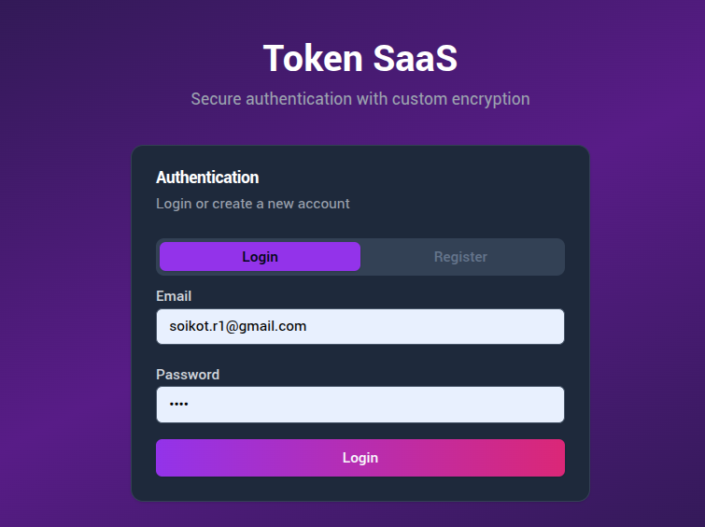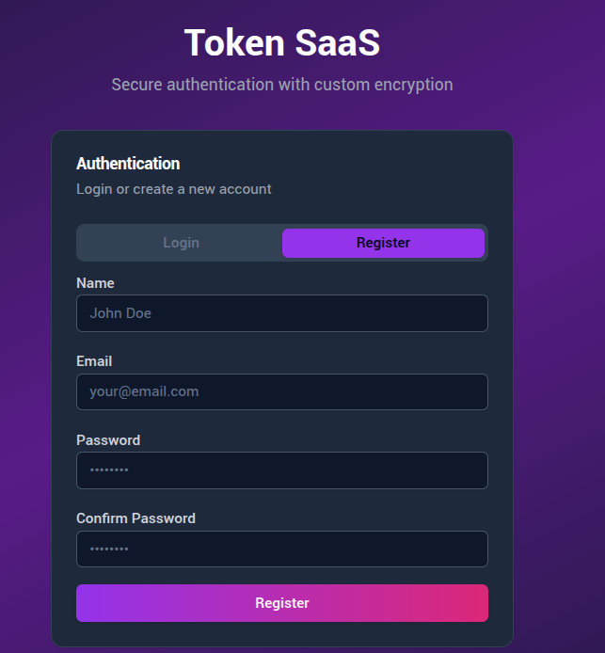
Figure 6: Authentication implementation - user login and registration

3.5.2. Authorization Enforcement
lib/accessControl.js implements tiered access:
FEATURES = {
free: ['basic_analytics_view', 'content_preview', 'limited_reports'],
basic: [...free, 'advanced_analytics', 'content_creation', 'standard_reports'],
premium: [...basic, 'real_time_analytics', 'ai_content_generation', 'api_access']
}

hasFeatureAccess(tier, featureId):
return FEATURES[tier]?.includes(featureId)
3.5.3. Permission Gating
ProtectedFeature component enforces runtime access:
function ProtectedFeature({ featureId, requiredTier, children, fallback }):
const { verifyUserToken, hasFeatureAccess } = useAccessControl()
const token = localStorage.getItem('token')
const verification = verifyUserToken(token)

if (!verification.valid || !hasFeatureAccess(verification.tier, featureId)):
return false
return true

Real-time synchronization: Custom events, cross-tab storage listeners, and visibility change handlers ensure immediate UI updates after subscription changes.

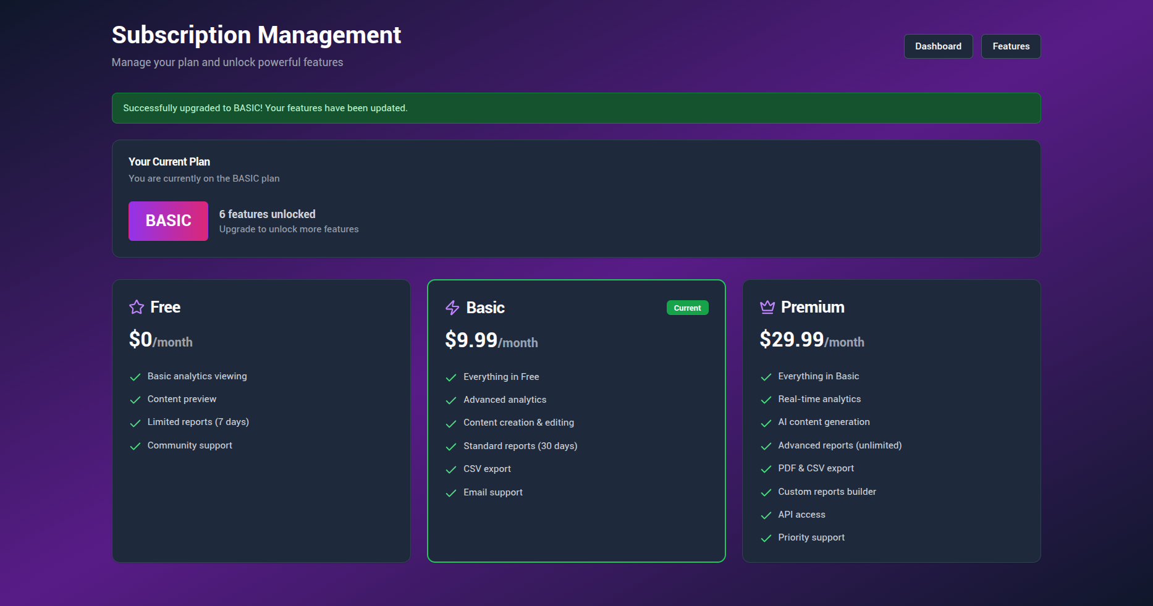

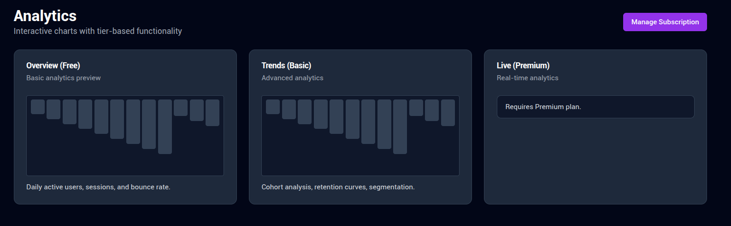
Figure 7: Authorization & Permission

Conclusion
This project successfully fulfills Programming Task 2 requirements by implementing three classical cryptographic methods—Group Substitution, Vigenère, and Transposition—with complete bidirectional functionality, plus a Diffie-Hellman key exchange bonus. The integration into a JWT-like token system within a Next.js SaaS platform demonstrates practical application of theoretical concepts while maintaining algorithmic transparency for educational purposes. The implementation serves as a valuable learning resource, enabling me to visualize encryption pipelines, experiment with token mechanics, and understand authentication/authorization models.

Future Enhancements:
- Migrate to server-side verification with modern cryptography (Web Crypto API)
- Implement additional classical methods (Playfair, Hill cipher)
- Add unit testing framework (Jest) for automated CI/CD
- Extend Diffie-Hellman with larger primes and security parameters
- Integrate proper database and production authentication

The project balances pedagogical clarity with functional completeness, providing a solid foundation for understanding cryptographic principles while explicitly acknowledging security limitations appropriate for its educational scope.

